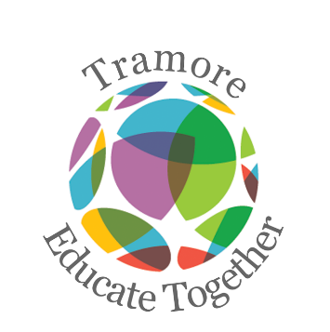
Tramore Educate Together National School
Fourth Class Booklist 2022-2023

Please purchase the following:
New Wave Mental Maths 4 (Prim Ed)
Just Handwriting Fourth Class (educate.ie)
Grammar 4 Pupil Book (Jolly Phonics)
Fallons Map Workbook 1 (Fallons)
8 x 88 page copy
2 x Sum Copy 88 pages
A4 Hardback Notebook
4 x A4 Plastic Folder
Tin whistle Scale D
2 x glue sticks, 4 x whiteboard markers
Blue, black and red pens, pencils, colouring pencils and pencil cases.
Please label the front cover of all his/her books and copies.
_____________________________________________________________________________________________________
Arts, stationery and additional money to be paid to school
Pupil Personal 24-hour Insurance € 7.00
Book Rental Scheme:
(Includes graded readers and Gaeilge and Maths Book) €20.00
Photocopying € 15.00
Arts & Crafts Materials € 20.00
Membership of Educate Together € 15.00
Homework School Diary € 4.00
________________________________________________________________________________________________________
Total Cost € 81.00
You will be sent an email with an Aladdin e-payment link to make an online payment. Thank you.

