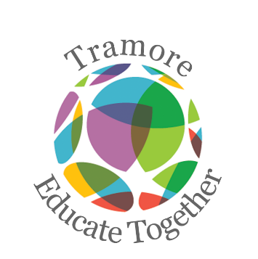
Tramore Educate Together National School
First Class Booklist 2022-2023

Please purchase the following:
Figure it Out 1st Class (CJ Fallon)
Just Handwriting First Class (Precursive) (educate.ie)
Grammar 1 Pupil Book (Jollyphonics)
6 x 15A Project Copy (Blank top half, lined bottom half)
1 x Junior Sum Copy 40 pages
2 x A4 Plastic Folder

Please label the front cover of all his/her books and copies.
All pencils and colours are provided in school.
_____________________________________________________________________________________________________
Arts, stationery and additional money to be paid to school
Pupil Personal 24-hour Insurance € 7.00
Book Rental Scheme:
(Includes graded readers) € 15.00
Photocopying € 15.00
Arts & Crafts Materials € 20.00
Membership of Educate Together € 15.00
Homework School Diary € 4.00
________________________________________________________________________________________________________
Total Cost € 76.00
You will be sent an email with an Aladdin e-payment link to make an online payment. Thank you.

