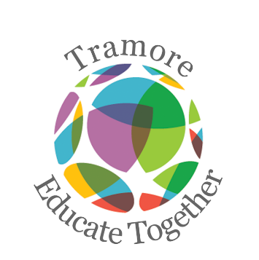
Tramore Educate Together National School
Third Class Booklist 2020-2021

Please purchase the following:
New Wave Mental Maths 3 (Prim Ed)
Grammar 3 Pupil Book (Jollyphonics)
Just Handwriting Third Class (educate.ie)
8 x 88 page copy
2 x Sum Copy 88 pages
6 x A4 Plastic Folder
Tin whistle Scale D
2 x glue sticks, 2 x whiteboard markers
Pencils, colouring pencils and pencil cases.
Please label the front cover of all his/her books and copies.
_____________________________________________________________________________________________________
Arts, stationery and additional money to be paid to school
Pupil Personal 24-hour Insurance € 7.00
Book Rental Scheme:
(Includes graded readers, Gaeilge and Maths Book) € 20.00
Photocopying € 15.00
Arts & Crafts Materials € 20.00
Membership of Educate Together € 15.00
Homework School Diary € 4.00
________________________________________________________________________________________________________
Total Cost € 81.00
We are in the process of setting up online payments for our school and we will share our Aladdin epayments details with you in September.

